Резюме

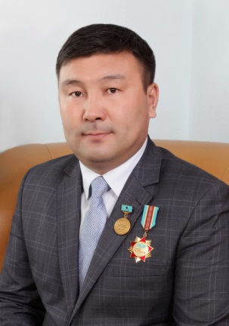 | Last name, First Name, Patronymic  (by ID card) | Baibatshanov Mukhtar Kassenuiy
 | Date of birth | 26.12.1977
 | Gender (male / female) | муж
 | Nationality | Kazakh
 | Civil service | Kazakhstan
 | Mobile phone,  E-mail | 87016620377,  Muxtar1977@mail.ru
Place of work: | KazNAU - " Forest resources and hunting»
Post: | Associate Professor
Academic degree, title: | Candidate of Agricultural Sciences.
Education: | Higher education: graduated from the Kazakh National Agrarian University in 2005 with honors in the specialty "Hunting and animal husbandry".
Work experience: | From September to December 2005, he worked as an assistant at the Department of Physiology and Morphology of the Kazakh National Agrarian University.  From 2005-2008, he studied full-time postgraduate studies in this specialty.  In December 12, 2008, he defended his PhD thesis on the topic "Productive qualities of quails in the local population".  In 2009-2010, he worked as an assistant at the Department of Animal Husbandry and Fisheries.  2009-2012. He studied in full-time PhD doctoral studies.  In 2012-2013, he worked as an assistant at the Department of " Technology of Production of Animal Products and Fish Farming»  2013-2016 worked as a senior lecturer of the Department of Forest Resources and Hunting Studies  Since 2017, Associate Professor at the Department of Forest Resources and Hunting Studies.
International internships | Mongolia 2011
Activities in the service sector (within and outside the institution): | "I don't know," he said. The facts are public in International, Republican and local developments. In 2003 (first among university students), stikhov's book "I am a guest"was published.
Scientific activity  Head and / or performer of R & D in the Republic of Kazakhstan | 2012-2015 RK SHS 212 "Research activities in the field of agro-industrial complex" in accordance with the budget program "Improvement of technologies for breeding, feeding farm animals, birds and fish in various regions of the Republic of Uzbekistan" was a researcher in priority area No. 2.
Training of highly qualified personnel | 10-head of the master's degree program
Authorship or co-authorship in research or development projects | Registered in the Ministry of justice of the Republic of Kazakhstan "Ecologially zoogeography Neger" (computer program-an electronic textbook). No. 2903, December 4, 2017
Educational and methodological publications: | More than 120 scientific works were published, including 18 textbooks and teaching aids, of which 1 textbook was published by the Ministry of education and science of the Republic of Kazakhstan, 5 recommendations of the Republic of Kazakhstan. "Quail farming"," Perepelovodstvo"," Quail production"," features of Quail breeding"," biology of perepelodstvo"," poultry farming"," types and crosses of agricultural birds"," net poultry farming of Kazakhstan"," short terminology words in poultry farming"," general hunting"," Hunting and hunting Russian-Kazakh-English-Latin translation dictionary"," fundamentals of ecological Zoogeography"," beekeeping"," technology of production of sheep and goat products in 1-2 volumes"," karakulevodstvo"," General zootechnics", " private zootechnics», "Rabbit breeding".
Scientific publications: | 120
Rewards  and rewards: | 2003-diploma holder of the VI International Festival of Creative Youth "Shabyt" (Astana)),  Awarded a letter of thanks from the UNESCO representative office in Kazakhstan.  For his contribution to the development of education in the Republic of Kazakhstan, he was awarded the medals "Alash Ustaz" and "Patriot of the Fatherland".  He was awarded the badge "For his contribution to agricultural education, science and production".  Winner of many sports competitions (Freestyle wrestling, arm wrestling, kettlebell lifting). Awarded numerous certificates.
Knowledge of languages: | Kazakh-fluent, Russian-fluent, English-with a dictionary
The composition of the family: | Married. 4-has a child.

